Evolution of cooperative personalities

By Joris Damhuis and Anna Wolters

Supervisor: Franjo Weissing

Introduction

Recently empirical research suggest that animals show different personalities within a population, which is described as different individual behaviour that is consistent over time (e.g. as a juvenile and as an adult) and context (e.g. in interaction with a predator and a potential mate).[1] This is not only true for animals, but is also found in birds, chimpanzees, fish, amphibians[2], spiders [3]and insects[4]. From an adaptive perspective an infinite plasticity of behaviour would be preferable, since an individual would have the right behaviour in any kind of situation. Than why is this not observed in the empirical data? Could some poorly understood evolutionary mechanism be at the core of this?

While aggressiveness and responsiveness have been subject to recent research, no models were created on cooperation personalities. Deciding what to do based on the signal the partner in the interaction has given, is the core part of the model we implemented for the Snow Drift game. The snowdrift game can evolve to coexistence under the right circumstances, where a more broadly used prisoner’s dilemma focusses more on the free-riding problem. In the prisoner’s dilemma no cooperation is expected, since it is an evolutionary unstable strategy.[5]

In this research we aim at cooperation evolving as different personalities under different responsiveness and signalling levels. Do different cooperative personalities evolve to coexist in populations of different levels of responsiveness and signalling? First, the snowdrift game is implemented. Later we will try to look at different games such as the prisoner’s dilemma and the stag-hunt game.

Snow drift game

*Fitness graph of the snow drift game. Benefits = 4, costs = 2.*

Above shows the fitness graph of the snowdrift game. The benefits and the costs are the same as used in the first parts of our model. On the x-axis the tendency to cooperate is given, where the y-axis shows the fitness. When the whole population defects (tendency to cooperate is zero) the best strategy to play is to cooperate. The equilibrium will move to the right, until the equilibrium is reached at about 0.67. When the tendency to cooperate is 1 for the whole population, it would be better to defect. The chance is very high you’ll receive the benefits, without the costs. This would push the equilibrium to the left. An evolutionary stable strategy is predicted at around 2/3 (0.67) of the population.

*Histograms, possibilities for personalities in the population.*

Above shows different possibilities for reaching the equilibrium of around 0.67. All three possibilities can explain the equilibrium. Therefore, the standard deviation is used, to see what the variation in the population is. When the standard deviation is small, it is likely that the whole population has a cooperation tendency of 0.67 (possibility 3). When the standard deviation is large, it could be that the population either goes to one of the extremes (possibility 1) or an intermediate from (possibility 2).

To see which of the cases we see in the models below, a distribution of the individuals of each population should show this. Also, the possible different emergence of personalities should be seen this way.

Model set-up

***Payoff matrix***

*General Snowdrift Benefits = 4, costs = 2*

$\begin{matrix}0 & α & β \\ α & a_{11} & a_{12} \\ β & a_{21} & a_{22}\end{matrix}$ $\begin{matrix}0 & C & D \\ C & b-\frac{1}{2}c & b- c \\ D & b & 0\end{matrix}$ $\begin{matrix}0 & C & D \\ C & 3 & 2 \\ D & 4 & 0\end{matrix}$

*Variation necessary for social responsiveness*

Payoff difference Δ between α and β (see general pay off matrix) is given by:

$$Δ= a_{12}- a_{22}-p* δ$$

And:

$$δ=\left(a_{12}- a_{22}\right)+\left(a_{21}- a_{11}\right)>0$$

For snowdrift pay-off matrix this is true:

$$δ=b-\frac{1}{2}c >0$$

$$δ=3 >0$$

Variation is only by mutation (rate = 0.1) in the first models. This should be larger than the costs:

$$Var \left(p_{0}\right)>\frac{c}{δ}= \frac{0.1}{3}≈0.033$$

$$SD\left(p_{0}\right) > \sqrt{\frac{c}{δ}}≈0.1825$$

Model 0.0

*Small overview variables*

* B (benefits) 4
* C (costs) 2
* μ (mutation rate) 0.01
* P0 (cooperation either 0 or 1) 0.05, 0.95, 0.67
* nI (number of interactions) 10

*Model set-up/traits*

Each individual has nI interactions in its life and gets fitness according to payoff matrix depending on strategies. Next generation based on fitness values. μ chance to change P0 state.

*Data overview*

*Above shows the development of the mean fraction of cooperatives in a population of three population with different initial conditions. The blue point represents the population with 95% cooperatives, grey with 67% and orange with 5%.*

The figure shows that the population goes to the predicted ESS around 2/3 of the population being a co-operator. The slight oscillations around the equilibrium are due to the stochasticity of the model (mutations).

Model 0.1

*Small overview variables*

* + B (benefits) 4
  + C (costs) 2
  + μ (mutation rate) 0.01
  + P0 (cooperation between 0 and 1) 0.05, 0.95, 0.67
  + nI (number of interactions) 10
  + σ (standard deviation of normal distribution used for change of P0) 0.01

*Model set-up/traits*

Everyone has nI interactions in its life. Gets fitness according to payoff matrix depending on strategies. Next generation based on fitness values. μ chance to change P0 by small amount taken from normal distribution with standard deviation σ).

*Data overview*

*Above shows the average P­­­0 of three populations. Blue represents the population where every individual has 95% tendency to cooperate with 0 variation. Orange is 5% cooperation, grey 67%.*

*The above shows the standard deviation of the average P0.*

The first figure shows the three different populations. The extreme values are considered to see if the equilibrium that is predicted is reached. The standard deviations show that the variation is relatively low, with some extreme outburst. This is probably due to stochasticity.

Model 1.0

*Communication*

Only honest communication is evolutionary stable. [6]

*Small overview variables*

* + B (benefits) 4
  + C (costs) 2
  + μ (mutation rate) 0.01
  + P0 (cooperation between 0 and 1) 0.05, 0.95, 0.67
  + nI (number of interactions) 10
  + σ (standard deviation of normal distribution used for change of P0) 0.01
  + Pi (obtain information either 0 or 1) 0.5

*Model set-up/traits*

* + Everyone has nI interactions in its life. Gets fitness according to payoff matrix depending on strategies if no info is present. If info is present, individual guesses what partner will do depending on P0 and pick optimal strategy based on it. Next generation based on fitness values. μ chance to change P0 by small amount taken from normal distribution with standard deviation σ. μ chance to change Pi state.

*Data overview*

The tendency to ask for information is 50% at every population. Three different population with different initial conditions were tested (95%, 67% and 5% tendency to cooperate).

The data is now still analysed in excel, later we use R to see spread plots and distributions.

*The above shows the average tendency for every generations in the three different populations. All three populations started at the tendency to ask information of 50%. The tendency seems to go to equilibrium around 0.2. Therefore, the level of responsiveness is quiet low.*

*The above shows the P0 of the populations. All end up at the expected equilibrium of around 0.67. The 5% cooperatives take a long time to reach the equilibrium.*

*Above shows the Pmean of the generations of three different populations. Clearly the 5% cooperative population slowly goes to the equilibrium.*

Form the above three graphs, it is seen that responsiveness is not totally extinct, but stays on a level around 0.2. This is expected form the article of Wolf, van Doorn and Weissing. [7]

The second thing seen is that in a population were in the beginning only 5% starts with cooperation, the information tendency stays high for quit longer. In correlation with that the P0 stays low and the Pmean stays high for about the same amount of time.

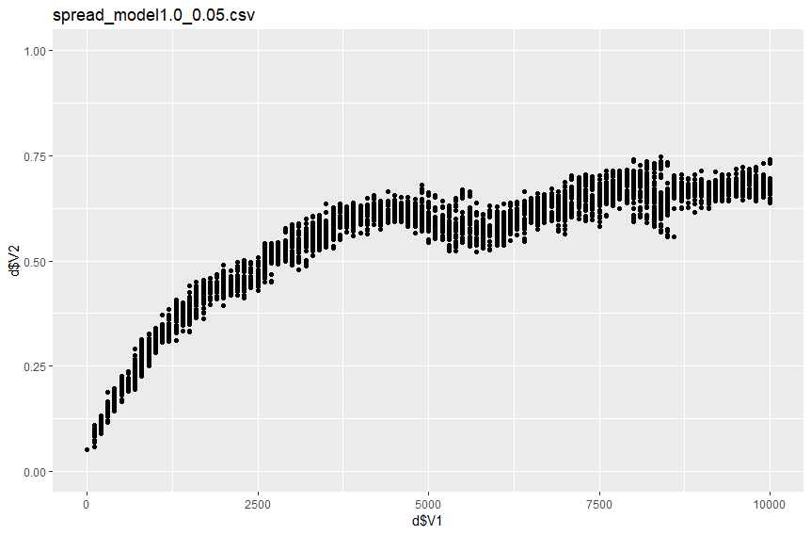

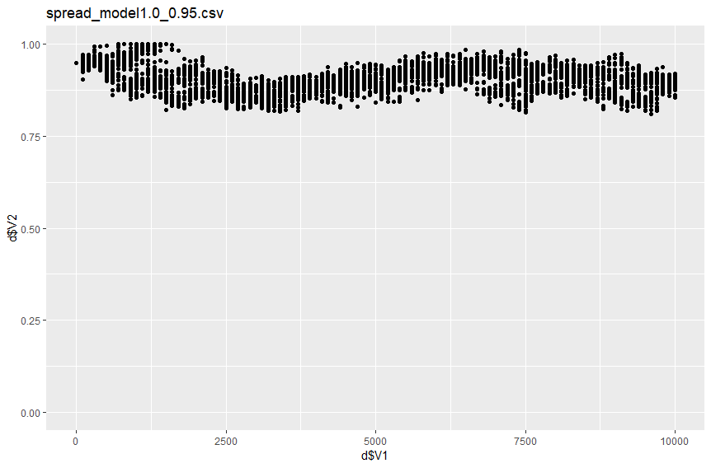

*Above shows three spread graphs for three different populations for model 1.0.*

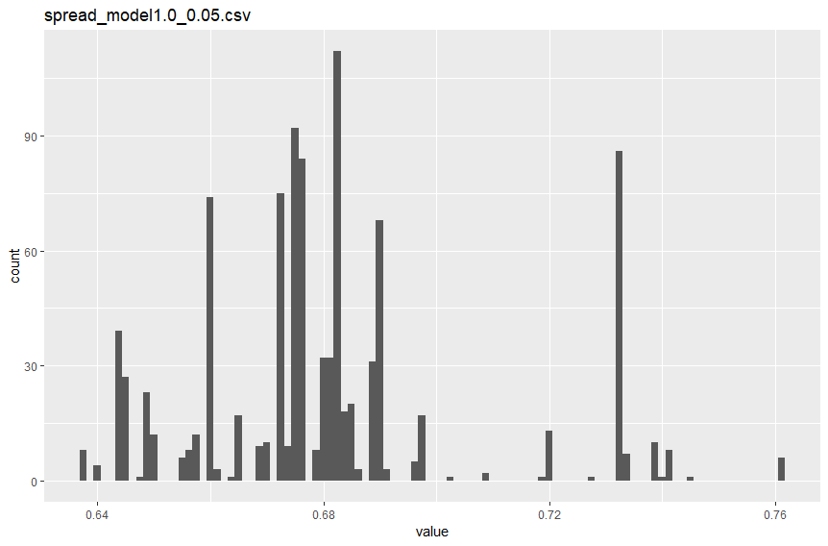

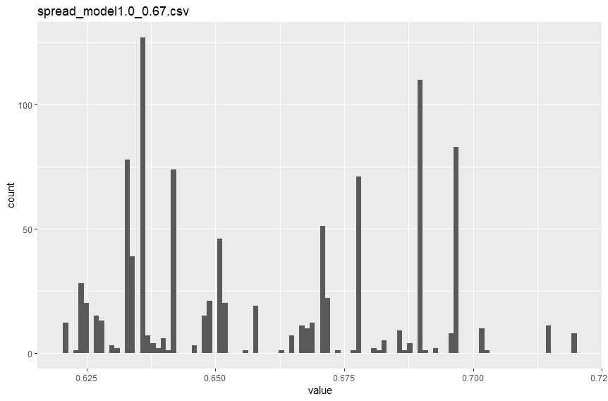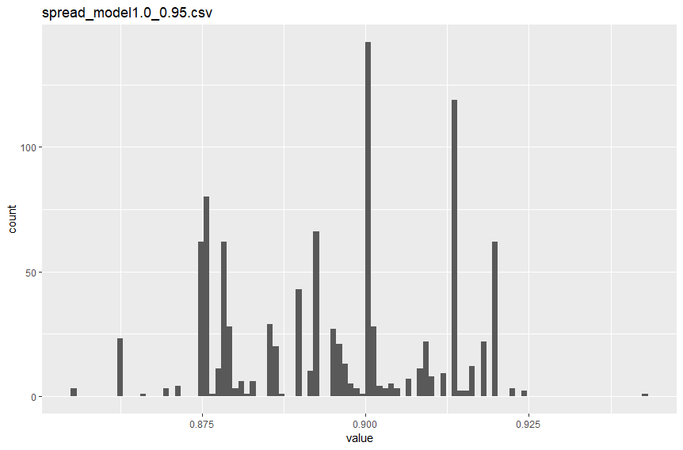

*Above shows the corresponding distribution of the last generation.*

The spread plot do not show an emerge of personalities.

*Problems with this model*

The responsive individuals in this model would base their next move on the P0 of the opponent instead of the Pmean. This would mean that the

Model 1.1

*Small overview variables*

* + B (benefits) 4
  + C (costs) 2
  + μ (mutation rate) 0.01
  + P0 (cooperation between 0 and 1) 0.05, 0.95, 0.67
  + nI (number of interactions) 10
  + σ (standard deviation of normal distribution used for change of P0) 0.01
  + Pi (obtain information either 0 or 1) 0.5

*Model set-up/traits*

Everyone has nI interactions in its life. Gets fitness according to payoff matrix depending on strategies if no info is present. If info is present, individual guesses what partner will do depending on P0 if it’s not a responsive individual, otherwise based on mean cooperation chance in previous generation, and pick optimal strategy based on it. Next generation based on fitness values. μ chance to change P0 by small amount taken from normal distribution with standard deviation σ. μ chance to change Pi state.

*Data overview*

We had several problems with this model, below shows correctly what the chances are to cooperate and defect when in an environment with responsive and unresponsive individuals.

Focal = f, opponent = t, C = cooperate, D = defect.

|  |  |  |
| --- | --- | --- |
| Partner  Focal | Responsive | Unresponsive |
| Responsive | Cf = 1- Pmean  Df = Pmean  Ct = 1- Pmean  Dt = Pmean | Cf = 1 - P0(t)  Df = P0(t)  Ct = P0(t)  Dt = 1 - P0(t) |
| Unresponsive | Cf = P0(f)  Df = 1 – P0(f)  Ct = P0(t)  Dt = 1 - P0(t) | Cf = P0(f)  Df = 1 – P0(f)  Ct = 1 - P0(f)  Dt = P0(f) |

*Above, four scenarios in model 1.1 are laid out an individual can be responsive and unresponsive and can interact with a responsive and unresponsive individual. It shows the chances an individual who is responsive or not responsive will do cooperate or defect when interacting with a responsive or not responsive individual. Cf = chance focal individuals cooperate, Df­ = chance focal individual defects, Ct and Dt­ are the same but than for an opponent. Pmean is the average strategy of the last generation, where P0 is the intrinsic.*

This

Model 1.1 nul (control on Model 1.1)

*Small overview variables*

* + B (benefits) 4
  + C (costs) 2
  + μ (mutation rate) 0.01
  + P0 (cooperation between 0 and 1) 0.05, 0.95, 0.67
  + nI (number of interactions) 10
  + σ (standard deviation of normal distribution used for change of P0) 0.01
  + Pi (obtain information either 0 or 1) 0.5

*Model set-up/traits*

This is a control model to see if an equilibrium is found in the information tendency. Therefore, no selection is made for the next generation based upon fitness. Instead of a weighted lottery, a Gaushy distribution is used.

*Data overview*

*Above shows the information tendency. This will oscillate around 0.5.*

*Above shows the tendency to cooperate as an average over the whole population.*

*Above shows the P0 of three replica populations and its standard deviation. As can be seen, the populations have little variation. This is due to only small mutation rate.*

The P0 of the blue population shows a large difference. This is only due to the drift of the small mutation rates.

*Problems with this model*

The case that an unresponsive individual would run into a responsive individual would never be picked. This we saw when counts were introduced for every interaction between responsive and unresponsive individuals. The problem was that instead of looking at the strategy, we looked at the responsiveness, the P0, of the individuals to calculate the fitness. Which resulted in a case were

Model 1.2

*Overview of variables*

*Model set-up*

*Data overview*

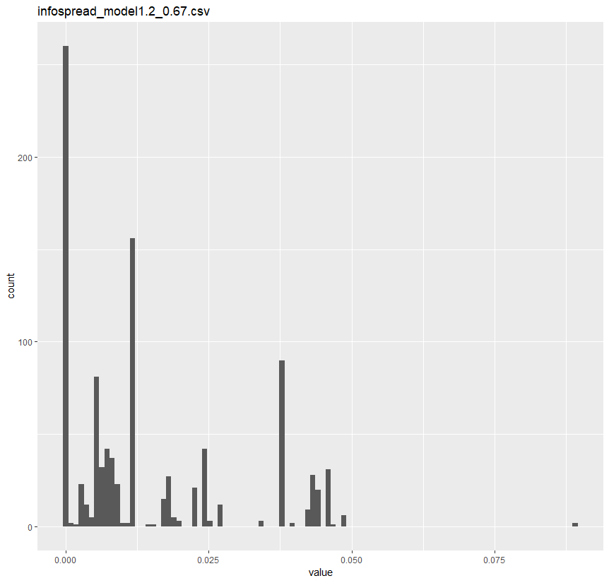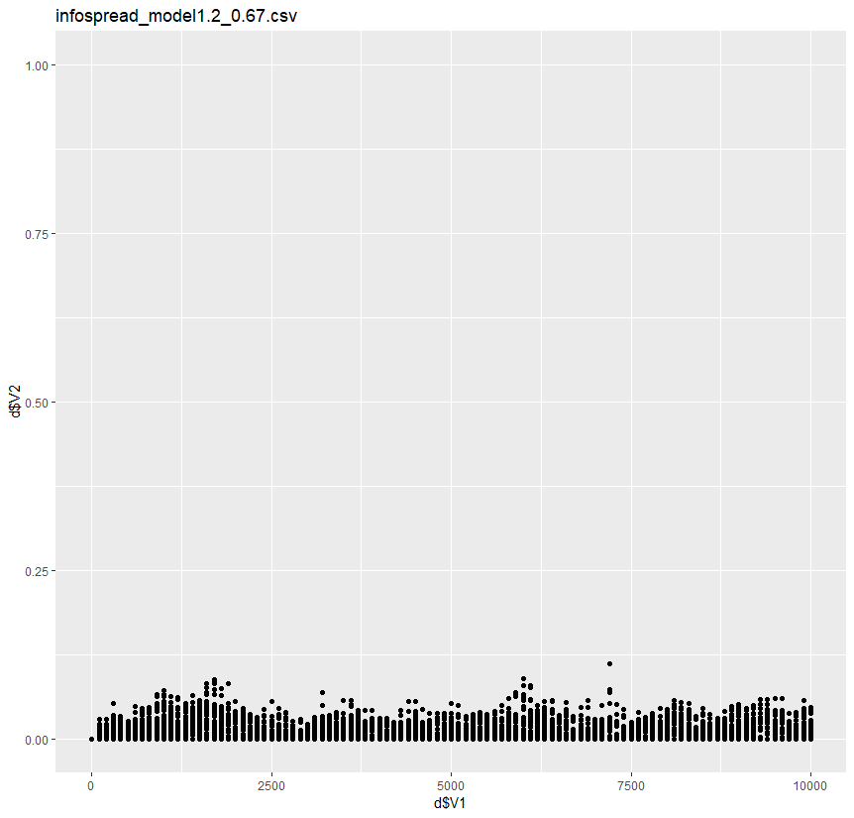

*Above data from model 1.2 is shown for the population that begins with 67%*

Possible extensions model/extra analysis

* Meta-populations
  + Randomly distribute the population into a community of size (between 20 and 100 or something). Than interactions only within community. Every generation, new randomly distributed meta-populations are defined. Unresponsive in population zero.
    - New meta-populations after every newly formed generation, because in our model no sexual reproduction is implemented.
  + Expectation: emerge of responsive individuals.
* Is there a correlation between information tendency and the P0? *Ido Pen*

Feedback presentations

* 17-12-2018
  + Correlation P0 and information tendency?

*Franjo:* the coexistence of unresponsive and responsive is to be expected.

* + Make clearer graphs
    - Different graphs for every initial condition
    - Don’t call the models by the numbers we give them ourselves, but more like the different scenario’s
  + Why does the information tendency go to approximately 0.2 (or 0.1 in model 1.1 new) instead of dying out completely?
  + Did we test different costs and benefits?

Should this make a difference other than changing the equilibrium of the ESS?

It could be that the it would influence the tendency to ask information.

Literature list

*Interesting not yet used literature:*

* Smaldino, P. E., Flamson, T. J. and McElreath, R. (2018) “The Evolution of Covert Signaling,” *Scientific Reports*, 8(1). doi: 10.1038/s41598-018-22926-1.

1. Sih, A., Bell A., Johnson J. C. (2004) “Behavioral syndromes: an ecological and evolutionary overview.” *Trends in Ecology and Evolution*. **19**, 372 – 378
2. Gosling SD (2001) “From Mice to Men: What Can We Learn About Personality from Animal Research?” *Psychological bulletin*, 127(1), pp. 45–86.
3. Johnson J. C. & Sih A. 2005 precopulatory sexual cannibalism in fishing spiders (*Dolomedes triton*): a role for behavioural syndromes. *Behav. Ecol. Sociobiol.* **58**, 390 – 396
4. Brodin, T. and Johansson, F. (2004) “Conflicting Selection Pressures on the Growth/predation-Risk Trade-Off in a Damselfly,” *Ecology*, **85**, pp. 2927–2932. doi: 10.1890/03-3120.
5. VOETNOOT NOG INVOEGEN
6. Botero, C. A., Pen, I., Komdeur, J., Weissing, F. J. and Doebeli, M. (2010) “The Evolution of Individual Variation in Communication Strategies,” *Evolution*, 64(11), pp. 3123–3133.
7. Wolf M., Van Doorn G. S. & Weissing F.J. 2010 On the coevolution of social responsiveness and behavioural consistency. *Proc. R. Soc. B*. **278,** 440 – 448

   